# **Sigmoid Neuron**

## **Sigmoid Model**

### **Model Part 2**

What happens when we have two inputs?

1. Consider y = 1/(1 + exp(-(w1x1 + w2x2 + b))
2. 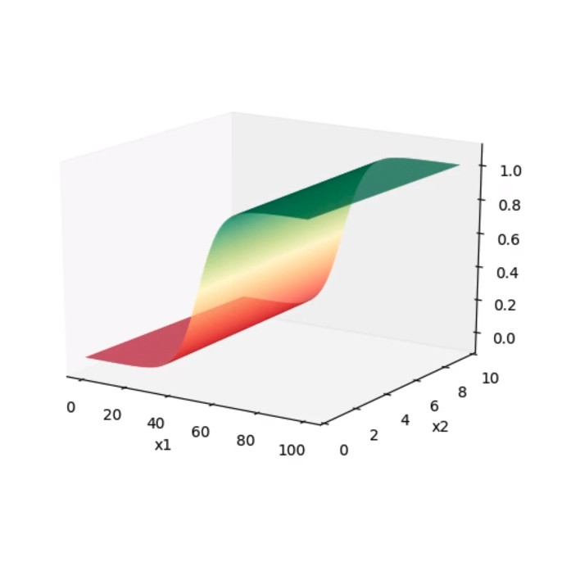
3. Substituting different values of w and x would result in the shape as seen in the curve above
4. Whenever w1x1 + w2x2 + b = 0, then y = 0.5